
Dear Parent(s)
As you know, spring is here, which brings our annual testing for students in all grade level. Students across the state will be testing with the Georgia Milestones End of Grade Test. The Georgia Milestones Assessment System (Georgia Milestones) is a comprehensive summative assessment program spanning grades 3 through high school. Georgia Milestones measures how well students have learned the knowledge and skills outlined in the state-adopted content standards in English Language Arts, mathematics, science, and social studies.
In preparation of the days to come, I have attached a Reading Log to help promote the reading stamina necessary for the assessments, a Reading Goals Sheet, to help identify and keep track of the students Lexile and reading level, as well as the student individual goals. I have included our Testing Schedule, along with ways in which you can support your student, so that s/he can experience great success this year. Additionally, below I have listed several Websites that students can utilize to practice for the test. Please note that the state law regarding promotion/retention will again be implemented in 2019 across Georgia. In order to be promoted, students must demonstrate on-grade level reading ability on the Georgia Milestones, as well as all other academic subjects.

Georgia Milestones End of Grade Study/Resource Guides
- GA Milestones Practice Tests & Curriculum Reviews

https://www.usatestprep.com/Georgia-Middle-School-online-review

- Lumos Georgia Milestones practice resources

https://www.lumoslearning.com/llwp/resources/gmas-practice-tests-sample-questions.html
- Georgia Milestones End of Grade Study/Resource Guides

http://www.gadoe.org/Curriculum-Instruction-and-Assessment/Assessment/Pages/EOG-Study-Resource-Guides.aspx

***Parents please encourage your kids to read at home every day***
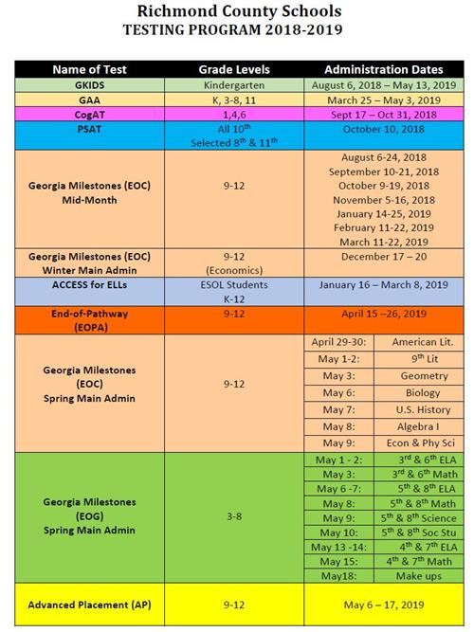
***Parents please encourage your kids to read at home every day***

Sincerely,
Mr. Jimmy Ulcena
Special Education Teacher

